General Ledger Accounting
For Virtual
Enterprise Students
Written By Jerry Belch
Copyright 2012

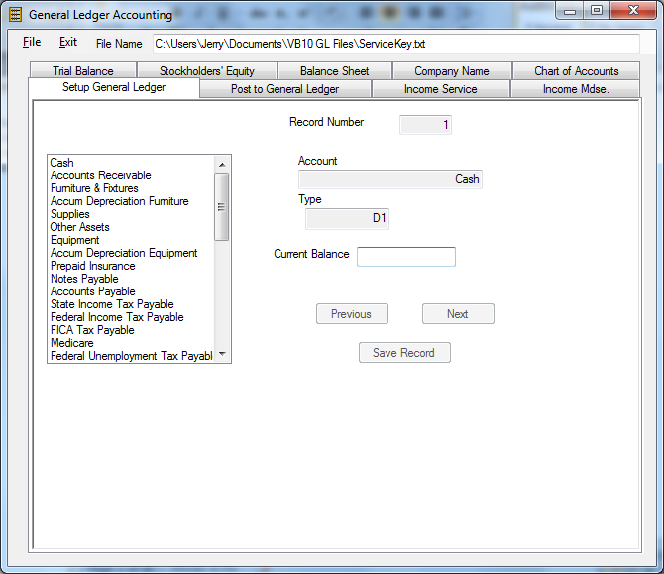

Purpose
Many of the Virtual Enterprise companies in the past have had trouble installing software on their school machines. Microsoft has developed a new technology called “Click Once”. With this new technology, desktop applications can be run directly from a web site. The applications do not have to be installed on client machines in the classroom or on your network. Install or setup programs in the past caused problems in that they sometimes would overwrite existing controls needed for other programs and caused these programs not to execute as they were designed to. With “Click Once” the program can be run directly on a web site. The user does not even need administrative privileges.
Visual Basic 10 allows the developer to accomplish this. There is a general ledger/financial statements program available to all VE students. It can be used to create a chart of accounts, beginning balance and projected income statement and breakeven analysis to be used in the business plan. With as few as 30 numbers to enter, you can create a chart of accounts, a beginning balance sheet showing you your business load transactions, an income statement that reflects you business contract with the Virtual Enterprise Center. A breakeven point can be found in minutes after keying in the standard payments and payroll information for your company
Two files have been created for you. They are a chart of accounts for a service business and a chart of accounts for a merchandising business, one that sells an inventory of goods. These files along with the actual program are located at http://www.janetbelch.com/freesoft.html. Click this link to take you to the location for the files and program.
Follow these steps to get a copy of the chart of accounts needed for your business.
Click on either service or merchandising chart of accounts. Both charts are text files, ( .txt) and will open in Notepad. Notepad is a program that comes with all Windows computers. It is a very basic text editor program. Look over the chart of accounts in Notepad. If you do not want to change any account names then, save the file on your computer. Use a name for the file that is representative of what the file contains. A good one would be “Your Company name November Books”. In Windows 7 you need to click on Page, then Save As, Find location for file and save it. Skip down the next section on how to run the program.
You will notice that first the account name is listed, followed by a couple of letters describing the type of account and then two numbers. The numbers represent the balance in the account. These charts of accounts are representative of most accounting charts. You probably will not need to change a thing unless you have some unusual accounts. DO NOT add or delete any accounts to the charts. The software works with the number of records in each file. If you change the number of accounts the program will not operate. Chart of accounts are listed in a particular order. Assets first, Liabilities, second, Stockholders equity next, Cost of Goods Sold for a merchandising business and then lastly Expenses.
I created a way to code each that the software recognizes. Assets, for example, are listed in this file as “D1”. This means that these accounts, which have a monetary value, are listed first in the ledger and have a debit balance.

D1 | Assets
D0 | Inventory
C1 | Accumulated Depreciation
C2 | Liability accounts
C3 | Capital Stock
C3R | Retained Earnings
C4 | Revenue Accounts
D4 | Sales returns
D5 | Purchase Account
D6 | Expense Accounts

If you must make changes, do so carefully. Only change the name of the account. Leave it in its current place. Do not change the type of account or the balances.

How to Run the Program

In the free VE software section of the web site under Software downloads click the link New General Ledger and then click Run. If you do not have the Net Framework it will automatically installed on your machine. All newer machines already have this framework installed. The program will be loaded into memory, but not installed. No harm can come to your computer. You should see the following:
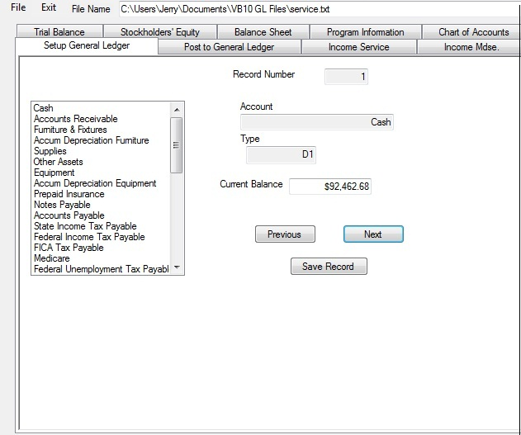
All controls are not available until you load the file. The very first assignment in the accounting tutorial is to create a chart of accounts. As you saw above there are two basic templates: One for a service business and one for a merchandising business. You should have already saved one of these files on your computer. These are accounts that would traditionally be used in an S corporation.

Retrieving the File
- Click File
- Click Retrieve
- Click OK
- In the Input box, type s if your business is a service business or type m for a merchandising business. Use lower case letters for both service and merchandising businesses.

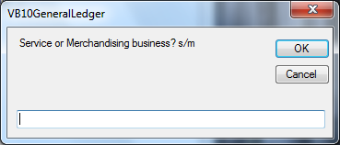

- Click OK
- In the Look In box, find which folder you saved, the service or merchandising file.
- Double click the folder
- Click on the file name
- Click Open
- Click on the tab for Chart of accounts.
- Click the see chart of accounts button.
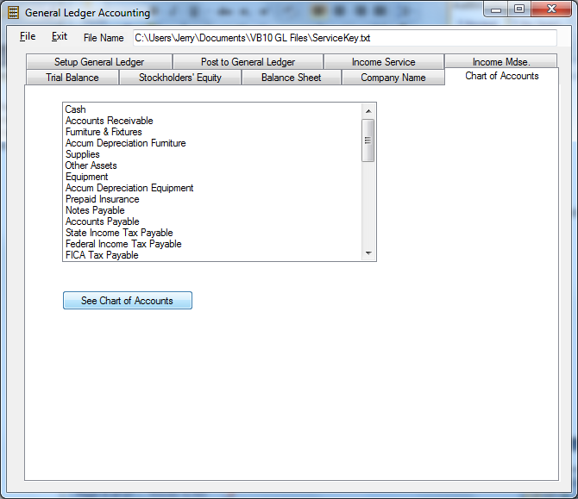

Setting Beginning Balances
- After retrieving the file, Click the Setup Tab

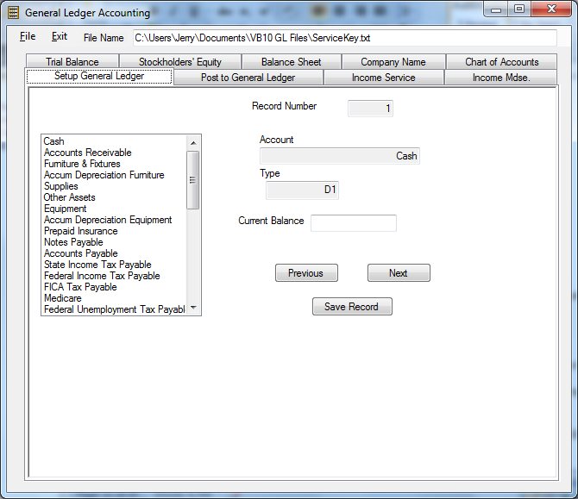

- You will see the above screen.
- The chart of accounts is in a box on the left in a scrollable box
- The service file has 40 accounts and the merchandising has 43.
- Record 1 is Cash, 2 is Accounts receivable, etc
- You can see each and its balance by using the Previous and Next Buttons
- When you get to the end of the file, The Next button is disabled because there are no more accounts.
- Use the Previous button to go back to the beginning record in the file.
- You can only change balance here. No changes can be made to account name or type.
- In the accounting tutorial, it states that most banks will not loan money to a company unless the owners have a vested interest in the company.
- In this example the CEO invests $15,000. The five Vice presidents each invest $10,000. The 20 employees invest $1,000 each. The total investment in this case is $85,000.
- Now let’s enter this information into our general ledger program.
- In every accounting transaction at least two accounts are affected. In this case Cash and Capital Stock.
- Use buttons to go to the cash record number 1
- In the current balance text box enter the amount of your initial investment. Use your own company’s data. For this example we are using $85,000
- Press the Save Record Button.
- Use the Next button to get to the Capital Stock Record.
- In the Current balance box enter the same number as you entered in the cash account.
- Click the Save Record Button.
- After changing any general ledger account we need to see if our ledger is in balance.
- Do the debit total equal the credit totals?
Company Information Tab
- Click on the company tab.
- This is where you enter the name of your company and the date you want to have printed on your statements
- You should see the following on your screen
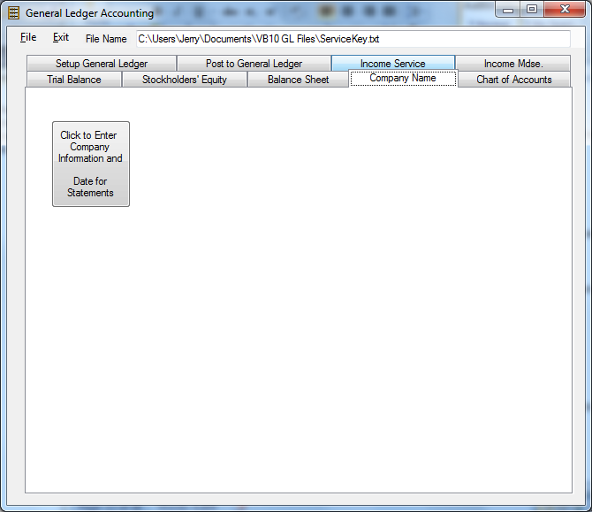
- Click on the button to enter the information.

Trial Balance
- Click on the Trial Balance Tab
- Click the Display Trial Balance Button.
You should see the following screen
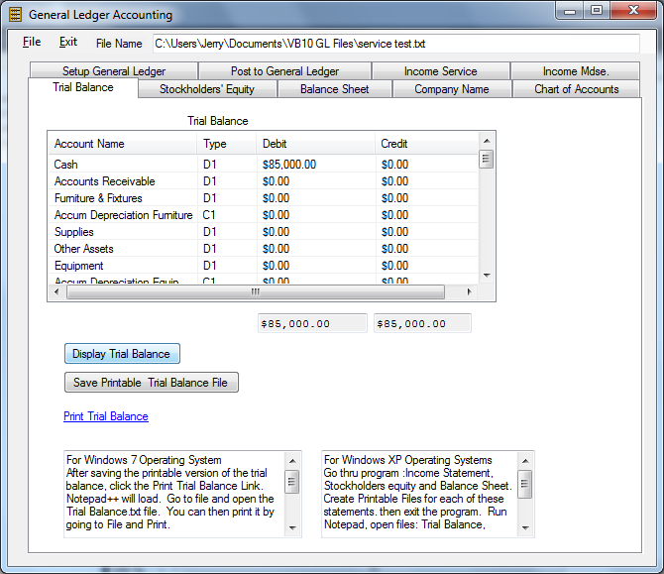
- You should the $85,000 in the Cash debit column
- Scroll down to see the Capital Stock account.
- It should show the $85,000 in the Credit Column
- The two text boxes at the bottom show the total of debits and total credits for all accounts.
- In double-entry accounting, these two numbers always need to be the same for our ledger to balance
- If you have additional setup proceed in this fashion
- To print out your trial balance, first click the Save Printable Trial Balance File. This action saves a properly formatted trial balance text file.
- Read the information in the two boxes below to see how to proceed with the printout.
- You may also run Notepad while using the program. Press the Window Key and the R key at the same time. This action allows you to run any program. Type in Notepad.exe and press OK. You can then open the file and print out your reports.
- A file called “Trial Balance.txt “is created for you in the folder you are working in.
- The other numbers can be entered using the Posting part of the program.

Business Loan
Most new companies need money to get started. As you can see we currently have money invested from the students in the class. In most cases more cash is needed.
The Virtual Enterprise Office will make a loan to your business. You will pay it back each month with interest. The money can be used for inventory, assets necessary to run your business and operating expenses. In the Accounting tutorial you have seen that there are two business used for the purpose of explaining the accounting material. Bromley’s Tuxedo Rentals, rents tuxedos and accessories. They do not sell anything. This is a service business. Bromley’s Men’s Wear carries a full line of men’s clothing and is a merchandising business. For the purpose of this program and the accounting tutorial the same amounts of items are needed for the business loan
Display Cases | $25,000.00
Clothing Racks | $20,000.00
Cash Register | $2,000
Computer | $1,500.00
Office Supplies | $500.00
File Cabinets | $300.00
Desk | $400.00
Chair | $100.00
Software | $1,000.00
Inventory | $100,000.00

You should use your own numbers to enter into the program. See Chapter 2 in the Accounting Tutorial as how to arrive at these numbers.
For demonstration purposes we I will use the numbers above. The total of these numbers is $150,800.00. That is the amount we will be asking for from the central office. Remember use your own company’s numbers for all the business loan information.
Proceed as follows to post these numbers to your general ledger. The two accounts affected are Cash and Notes Payable. We will be debiting Cash $150,800 and Crediting notes Payable $150,800.00

Posting Business Loan Transactions

Proceed as follows:
- Run the program from the web site
- Retrieve your file
- Click the See Accounts button
- Click on the Posting tab. Your screen should look like this.

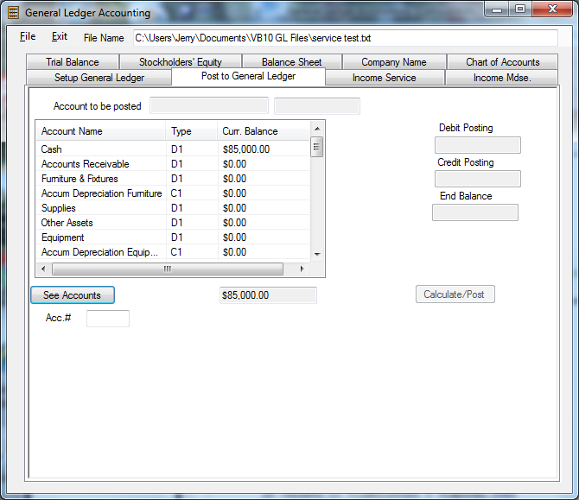

- This transaction involves two accounts: Cash which we will debit and Notes Payable which we will credit.
- In the box to the left, click on Cash. It will appear above in the box called account to be posted. The balance also appears right next to the account to be posted box.
- Click in the Debit Posting box.
- Key in the amount of cash we received from the load, 15800. Enter the only the amount. Do not enter dollar sign or commas.
- Click the Calculate/Post button to save a new balance for cash.
- The ending balance will show in the box next to ending balance, 235000
- Since we want to post another number, click on the radio button Yes. You will notice that the new balance for cash appears next to the account name in the scroll box at the left.
- Now we need to post the second part of the entry to Notes Payable as credit.
- Scroll down until you see notes payable.
- Click on it.
- Key in 15800 in the credit posting box.
- Click Calculate/Post button
- The account will be posted.
- Since we have no more postings, let us see if we are in balance.
- Click on the Trial Balance tab.
- Click Display Trial Balance.
- Both debit and credit totals should match at 235,000.00
- Scroll down to see individual amounts for each account. Cash should be at $235,000. Notes Payable will be at $!50,800.00
- Common Stock will be at $85,000.

- We need to see what purchases applied to which accounts. Furniture and fixtures is composed of Display case; $25,000.00, Clothing racks, $20,000; Cash register, $2,000.00 for a total of $47,000.00. For equipment total, add computer, file cabinets, desk and chair. Total is $2,300.00. Add software and office supplies together for a total of $1,500
- We will continue with posting these additional amounts. I Post the 100,000 to the inventory account.

Account Name Debit Credit
Cash |  | 150800
Furniture and fixtures | 47000
Equipment | 2300
Inventory | 100000
Office supplies | 1500

- Post each account just like the ones you did above
- To check for the accuracy of the postings, Click on the Trial Balance tab.
- Click on Display Trial Balance button.
- Your totals should be $235,800.00
- If you are not in balance, determine what went wrong. Maybe you posted a debit for a credit or entered an incorrect number. Use the posting or set up balance tab to correct you error.

Beginning Balance Sheet
Note: Click on the income mdse tab and enter the amount of ending inventory when prompted. This number is also your beginning inventory amount. This step is necessary to have the inventory amount appear on the beginning balance sheet.
- Click on the Balance Sheet Tab and printout the Balance Sheet. This is your beginning balance sheet for your business plan.
- When you click on the Display Balance Sheet button you will see the following message
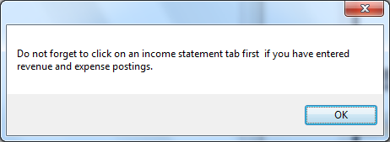
- Click OK. We have not entered any revenue or expenses at this point.
- See Instructions for printing under the trial balance section

Posting the transaction for payment of the Note Payable

We need to record the entry to pay off our Note to the Virtual Enterprise Center.
In the accounting tutorial the there is a link to a loan calculator. We pay the same each month, but the interest and the principal change. The interest part is higher during the early part of the loan. In our example we borrowed $150,800.

Account Name Debit Posting Credit Posting
Cash |  | 2163.54
Notes Payable | 655.54
Interest Expense | 1508
- Proceed to post this entry to make the first payment on your business loan
- Click on the Trial Balance tab to verify accuracy of posting this entry.

Posting the entry to record Depreciation
- Check Accounting tutorial to see values and depreciation schedules for each of these assets
Account name Debit Posting Credit Posting
Depreciation expense | 491.12
Accumulated Dep Furniture |  | 375
Accumulate Dep Equipment |  | 116.12

Posting Company Expenses
In the accounting tutorial you saw that you have a number of expenses that need to be paid to the VEC each month. There is a list of standard payments for companies. Some expenses are fixed others are variable based on the number of students in the class. My example is based on 20 students in the class.
Account Name Debit Credit
Cash |  | 9925.00
Rent Expense | 3500
Repairs expense | 50
Alterations Expense | 1500
Advertising Expense | 2000
Supplies Expense | 150
Insurance Expense | 750
Miscellaneous Expense | 100
Utilities Expense | 1875

Use your own numbers. For demonstration purposes, I used the numbers in the table above.
- Post these numbers and display a trial balance. Make sure that both debit and credit totals are equal.
- Printout a trial balance if you wish.

Business Contract
The Virtual Enterprise Center makes a business contract with your company to buy a certain amount of service or goods from your company each month. The purpose of the contract is to give you some sales and cash so that you can operate. You will need to do considerably more to break even or make a profit. Open houses, trade shows and grand openings, and Internet sales are the ways to accomplish this. The amount of the contract is determined by your total salary expense. If you have a merchandising business, there is an additional amount for cost of goods sold. Read the accounting tutorial, the chapter on the business loan for detailed instructions as how to obtain the amount of the loan. The payroll, gross pay for all employees is $83,328.00
Payroll Register
Last Name | First Name | Marital | Exemp | Pay Rate | Hrs Worked | Regular Pay |  | Overtime Pay | Total Pay | Federal Income | FICA | Medicare | State Income TX | SDI | State Train | Total Deductions | Net Pay
CEO |  | S | 1 | 52.08125 | 160 | $ 8,333.00 | - | $ - | $ 8,333.00 | $ 1,971.46 | $ 516.65 | $ 120.83 | $ 571.67 | $ 41.67 | $ 8.33 | $ 3,230.60 | $ 5,102.40
CFO |  | S | 1 | 49.47500 | 160 | $ 7,916.00 |  |  | $ 7,916.00 | $ 1,833.85 | $ 490.79 | $ 114.78 | $ 534.14 | $ 39.58 | $ 7.92 | $ 3,021.06 | $ 4,894.94
VP Sales |  | S | 1 | 33.85000 | 160 | $ 5,416.00 |  |  | $ 5,416.00 | $ 961.08 | $ 335.79 | $ 78.53 | $ 309.14 | $ 27.08 | $ 5.42 | $ 1,717.04 | $ 3,698.96
VP Marketing |  | S | 1 | 44.26875 | 160 | $ 7,083.00 |  |  | $ 7,083.00 | $ 1,558.96 | $ 439.15 | $ 102.70 | $ 459.17 | $ 35.42 | $ 7.08 | $ 2,602.48 | $ 4,480.52
VP Advertising |  | S | 1 | 44.26875 | 160 | $ 7,083.00 |  |  | $ 7,083.00 | $ 1,558.96 | $ 439.15 | $ 102.70 | $ 459.17 | $ 35.42 | $ 7.08 | $ 2,602.48 | $ 4,480.52
VP Human Res |  | S | 1 | 44.26875 | 160 | $ 7,083.00 |  |  | $ 7,083.00 | $ 1,558.96 | $ 439.15 | $ 102.70 | $ 459.17 | $ 35.42 | $ 7.08 | $ 2,602.48 | $ 4,480.52
Sales Assist 1 |  | S | 1 | 23.43750 | 160 | $ 3,750.00 |  |  | $ 3,750.00 | $ 544.58 | $ 232.50 | $ 54.38 | $ 159.20 | $ 18.75 | $ 3.75 | $ 1,013.16 | $ 2,736.84
Sales Assist 2 |  | S | 1 | 23.43750 | 160 | $ 3,750.00 |  |  | $ 3,750.00 | $ 544.58 | $ 232.50 | $ 54.38 | $ 159.20 | $ 18.75 | $ 3.75 | $ 1,013.16 | $ 2,736.84
Sales Assist 3 |  | S | 1 | 23.43750 | 160 | $ 3,750.00 |  |  | $ 3,750.00 | $ 544.58 | $ 232.50 | $ 54.38 | $ 159.20 | $ 18.75 | $ 3.75 | $ 1,013.16 | $ 2,736.84
Sales Assist 4 |  | S | 1 | 23.43750 | 160 | $ 3,750.00 |  |  | $ 3,750.00 | $ 544.58 | $ 232.50 | $ 54.38 | $ 159.20 | $ 18.75 | $ 3.75 | $ 1,013.16 | $ 2,736.84
Payroll Clerk |  | S | 1 | 33.85000 | 160 | $ 5,416.00 |  |  | $ 5,416.00 | $ 961.08 | $ 335.79 | $ 78.53 | $ 309.14 | $ 27.08 | $ 5.42 | $ 1,717.04 | $ 3,698.96
A/R Clerk 1 |  | S | 1 | 33.85000 | 160 | $ 5,416.00 |  |  | $ 5,416.00 | $ 961.08 | $ 335.79 | $ 78.53 | $ 309.14 | $ 27.08 | $ 5.42 | $ 1,717.04 | $ 3,698.96
A/R Clerk 2 |  | S | 1 | 33.85000 | 160 | $ 5,416.00 |  |  | $ 5,416.00 | $ 961.08 | $ 335.79 | $ 78.53 | $ 309.14 | $ 27.08 | $ 5.42 | $ 1,717.04 | $ 3,698.96
Banker |  | S | 1 | 33.85000 | 160 | $ 5,416.00 |  |  | $ 5,416.00 | $ 961.08 | $ 335.79 | $ 78.53 | $ 309.14 | $ 27.08 | $ 5.42 | $ 1,717.04 | $ 3,698.96
Web Design |  | S | 1 | 23.43750 | 160 | $ 3,750.00 |  |  | $ 3,750.00 | $ 544.58 | $ 232.50 | $ 54.38 | $ 159.20 | $ 18.75 | $ 3.75 | $ 1,013.16 | $ 2,736.84
Totals |  |  |  |  | 2400 | $ 83,328.00 |  |  | $ 83,328.00 | $ 16,010.51 | $ 5,166.34 | $ 1,208.26 | $ 4,825.02 | $ 416.64 | $ 83.33 | $ 27,710.09 | $ 55,617.91
Federal Income Tax
>2625 and < 5813 is a 25% tax Bracket
>5813 and <12,663 is a 33% tax Bracket
State Income Tax
All employees are in the 9% tax bracket
Payroll Taxes
Medicare | $ 1,208.26
FICA | $ 5,166.34
FUTA | $ 666.624
SUTA | $ 2,833.15
State Training | $ 83.33
Total Due | $ 9,957.70
- The employer, your company is responsible for sending the deductions that were withheld from each employees checks to the IRS and State Board of Equalization each quarter
- In addition to sending those withheld amounts in each quarter, your company is responsible for the payroll taxes. Payroll taxes are taxes on the employer and include matching amounts for Medicare and FICA, FUTA and SUTA, and a state training tax. As you can see from the spreadsheet above this amounts to $9,957, 70. Yours will, of course, vary due to your payroll register.

Posting Entries for Merchandising Business
- The contract for a merchandising business includes an amount to help cover some of the cost of goods sold.
- To calculate you need to know what the cost of goods sold is for your type of business. In the accounting tutorial there is a link to Biz Stats
- The cost of goods sold for our menswear company is .587
- Multiply .587 times $83,328.00 to get $48,913.54 cost of goods sold
- Add the amounts together $83,328.00 + $48,913.54 = $132,241.53 to get the amount of the business contract.
- Using the posting part of the program, key in the transactions below. Do not include the Additional Transactions at this point. We will put them in later.
Merchandising Business Journal Entries
Account Name | Debit | Credit
Investment
Cash | 85,000.00
Capital Stock |  | 85,000.00
Business Loan
Cash | 150,800.00
Note payable |  | 150,800.00
Buying Assets
Cash |  | 150,800.00
Furniture | 47,000.00
Equipment | 2,300.00
Office Supplies | 1,500.00
Inventory | 100,000.00
Paying Note
Cash |  | 2,163.54
Note Payable | 655.54
Interest Expense | 1,508.00
Depreciation
Depreciation Exp | 491.12
Accum Equip |  | 375.00
Accum Dep Furniture |  | 116.12
Expenses
Cash |  | 9,925.00
Rent | 3,500.00
Repairs | 50.00
Alterations | 1,500.00
Advertising | 2,000.00
Supplies Expense | 150.00
Insurance | 750.00
Misc | 100.00
Utilities | 1,875.00
VE Contract
Cash | 132,241.53
Sales VE Contract |  | 132,241.53
Salary
Cash |  | 55,617.91
Salary Expense | 83,328.04
FICA |  | 5,166.37
Medicare |  | 1,208.26
Federal Income Tax |  | 16,010.51
SDI |  | 416.64
State Income Tax |  | 4,825.02
State Training |  | 83.33
Payroll Taxes
Payroll Taxes Expense | 9,957.70
FICA |  | 5,166.34
Medicare |  | 1,208.26
FUTA |  | 666.62
SUTA |  | 2,833.15
Training Tax |  | 83.33
Purchases
Cash |  | 48,913.54
Purchases | 48,913.54
Add. Trans.
Cash | 133,000.00
Open House Sales |  | 133,000.00
Cash |  | 100,000.00
Purchases | 100,000.00
Totals | 906,620.47 | 906,620.47

- Click on the Income statement tab for a merchandising business
- Click the Display income statement button
- Enter 0 as the ending inventory number
- As you can see you lost money. You have a negative gross profit of 16,672.01 and net loss of 121,881.87 and a break-even point of 254,123.40.
- The VEC business contract does not cover your expenses. You need to have an open house, grand opening and Internet sales to make up this deficit.
- Now let’s enter the additional entries to see what happens
- Using the Posting tab, enter the additional transactions
- Since we are projecting additional sales we need additional purchases to increase our inventory.
- Click the Trial Balance Tab to verify that you are still in balance after posting these additional transactions.
- Now let’s examine the trial balance to help us determine the true ending inventory.
- To calculate ending inventory do the following
- Add beginning Inventory and purchases to determine cost of goods available for sale. (100,000 + 148,913.54) = 248,065.71
- Add sales from VE contract to Sales at Open house (132,241.53 + 133,000 = 265,241.53)
- Calculate Cost of Goods Sold by multiplying .587 times total sales of 265,241.53. (265,241.53 * .587) =155,696.77.
- Now subtract cost of goods sold from goods available for sale. (248,913.54 – 155,696.77) =93,216.77
- Our ending inventory based on the gross profit inventory evaluation method is 93,216.77
- Click on the Income Statement for merchandising business.
- Click on the display income statement
- Enter ending inventory of 93,216.77
- Your screen should look like the following.
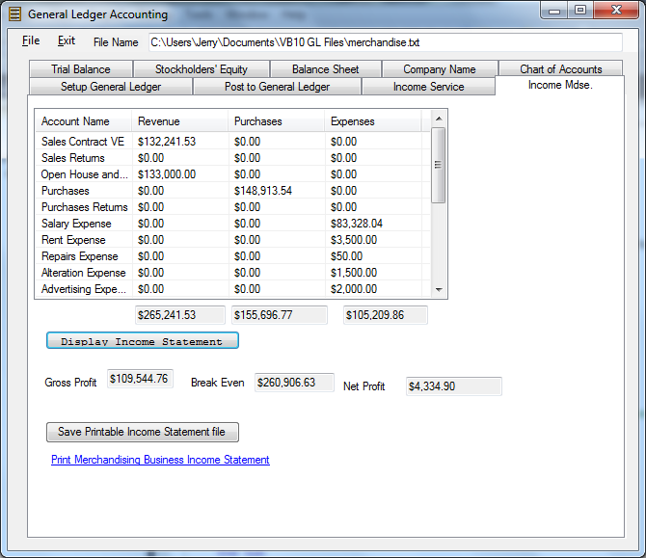
27 Printout the income statement
Stockholders’ Equity
- Click on the Stockholders’ Equity Tab
- Display the statement.
- It should look like the following example
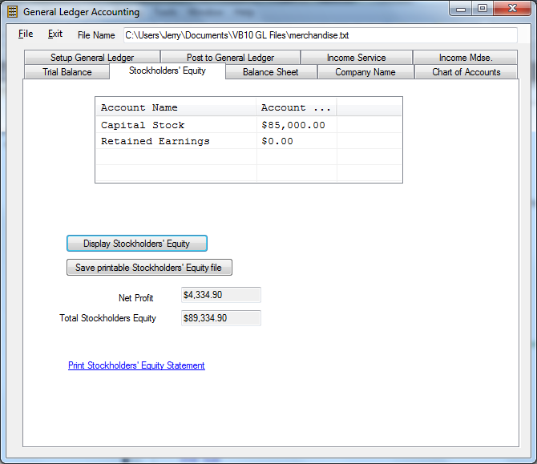
- Save the printed version.
- Printout the report

Balance Sheet

- Click on the Balance Sheet and Display the statement
- It should look like the figure below.
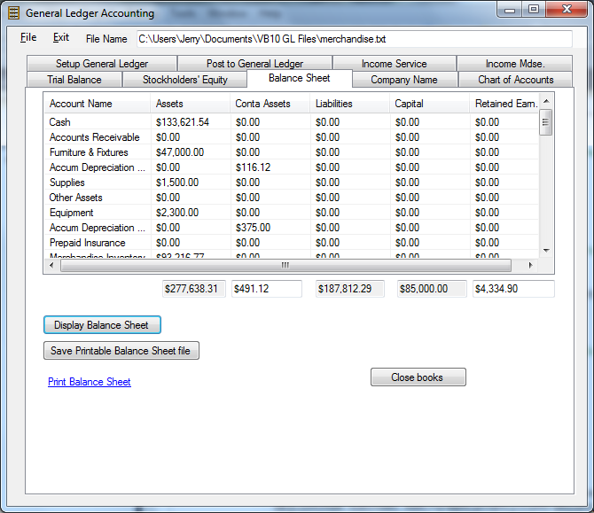
- Save Printable Balance Sheet file
- Printout balance sheet
- Close the books. Create a file in your student folder . A good name might be November Closed.txt. for the month of November. This is the file that is to be retrieved to do next month’s books. All revenue and expenses are set to zero and the difference is transferred to the Retained Earnings Account. If it is a merchandising business then the beginning inventory is set to the ending inventory.

